(Please submit this form by e-mail)
Deadline：July 31, 2026

To:
Organizing Committee of INTERPRAEVENT International symposium 2026
（E-mail：interpraevent2026@kokusaisabo.or.jp）

DD/MM/YYYY

Application Form for Company Advertisement

We hereby apply to place the company advertisement in the INTERPRAEVENT2026 materials distributed and on the website as follows.

Number of pages requested for advertisement | Page(s)
Regarding the placement of company logo on the website | Requested / Not requeste  Link URL to the company's website:
Total Amount | ￥ 円（tax included）  (Advertisement：\55,000円/1 page (tax included))  (Logo：\11,000円/1 kind (tax included))
Name of Company
Name of Representative
Contact Information  (Administrative Contact) | Address:  Department:  Position / Name:  Telephone:  E-mail;
Receipt Required | Required Not required
Remarks / Special Notes | ※Please specify if the billing name, date, or invoice mailing address differs from the above.
The materials distributed will be A4 size.

Preparation Guidelines for Advertisements
- It will be published in the materials distributed on the day of INTERPRAEVENT2026 and will also be posted on the INTERPRAEVENT2026 Abstracts website (tentative title).
- Please refer to the following instructions and prepare the material on A4 paper within 27.0 cm (height) × 18.0 cm (width) and provide the data in PDF format.
- The language used is English only, or both Japanese and English.
- If you wish to apply for the placement of a logo on the website, please send the logo image data (such as JPG or PNG) together with the application form.
- After you submit your application, we will send you an invoice, and we kindly ask you to arrange the payment by bank transfer. Regarding your logo, it will be posted on our website as soon as we confirm receipt of your payment.

Deadline：July 31, 2026
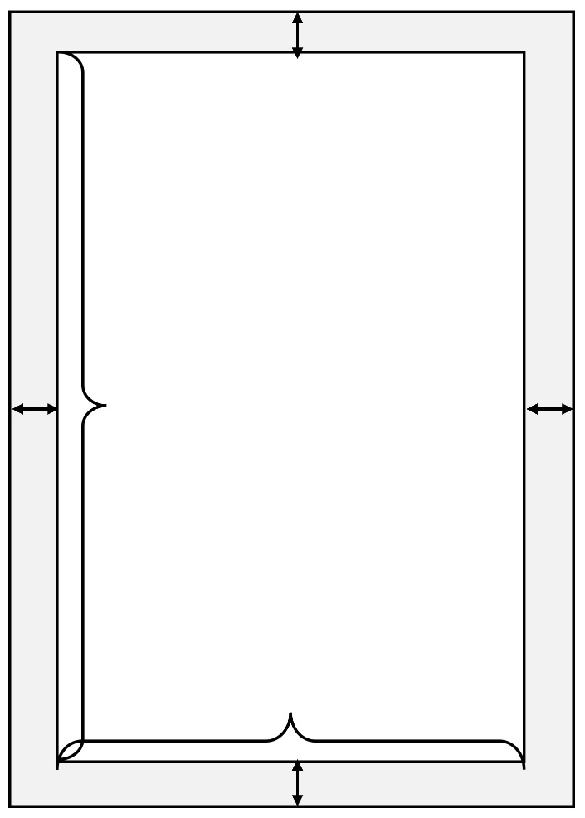
A4 size paper
15mm
15mm
13mm
14mm
Within 27.0cm
Within 18.0cm
Submission Address:
Organizing Committee of INTERPRAEVENT International symposium 2026
Secretariat staff: NORO Tomoyuki, NOMA Daisuke
Sabo Kaikan, 2-7-4, Hirakawa-cho, Chiyoda-ku, Tokyo 102-0093, Japan
E-mail interpraevent2026@kokusaisabo.or.jp
Language：English only, or both Japanese and English

・The paper is A4 size
・The top margin should be at least 13 mm
・The bottom margin should be at least 13 mm
・The margins on both sides should be at least 15 mm

